INFLUENCE of HEAT of TRANSFORMATION on PROCESS of
a CRYSTALLIZATION of GALLIUM PHOSPHIDE at LIQUID-PHASE EPITAXY

Emelyanov V.V., Huhryanskiy J.P., Shunikov E.A.
Voronezh State Technical University (Voronezh, Russia)
eu_sh@mail.ru

The method of the molecular dynamics leads examinations of process of growth of a crystal of gallium phosphide from a liquid phase to the initial moment of time.

During experiments the number of molecules taking place on surfaces of a crystalline phase, blanket number adsorbed and desorbed atoms, and accordingly and quantity of allocated (immersed) heat was checked.

As have shown experiments, at the first moment of time temperature on a demarcation of phase (fig. 1) sharply raises (the growth caused by an odds of temperatures), and then starts to be reduced (partial desorption of atoms). The come equipoise is dynamic. Thus the free atoms of gallium participate in process adsorption - desorption in basic. The phosphorus which is taking place at the first moment of time in a solution in part is besieged on a crystal during growth and forms in a solution with atoms of gallium clusters which are germs of a solid phase, but in connection with non-stoichiometric a composition do not participate during growth.

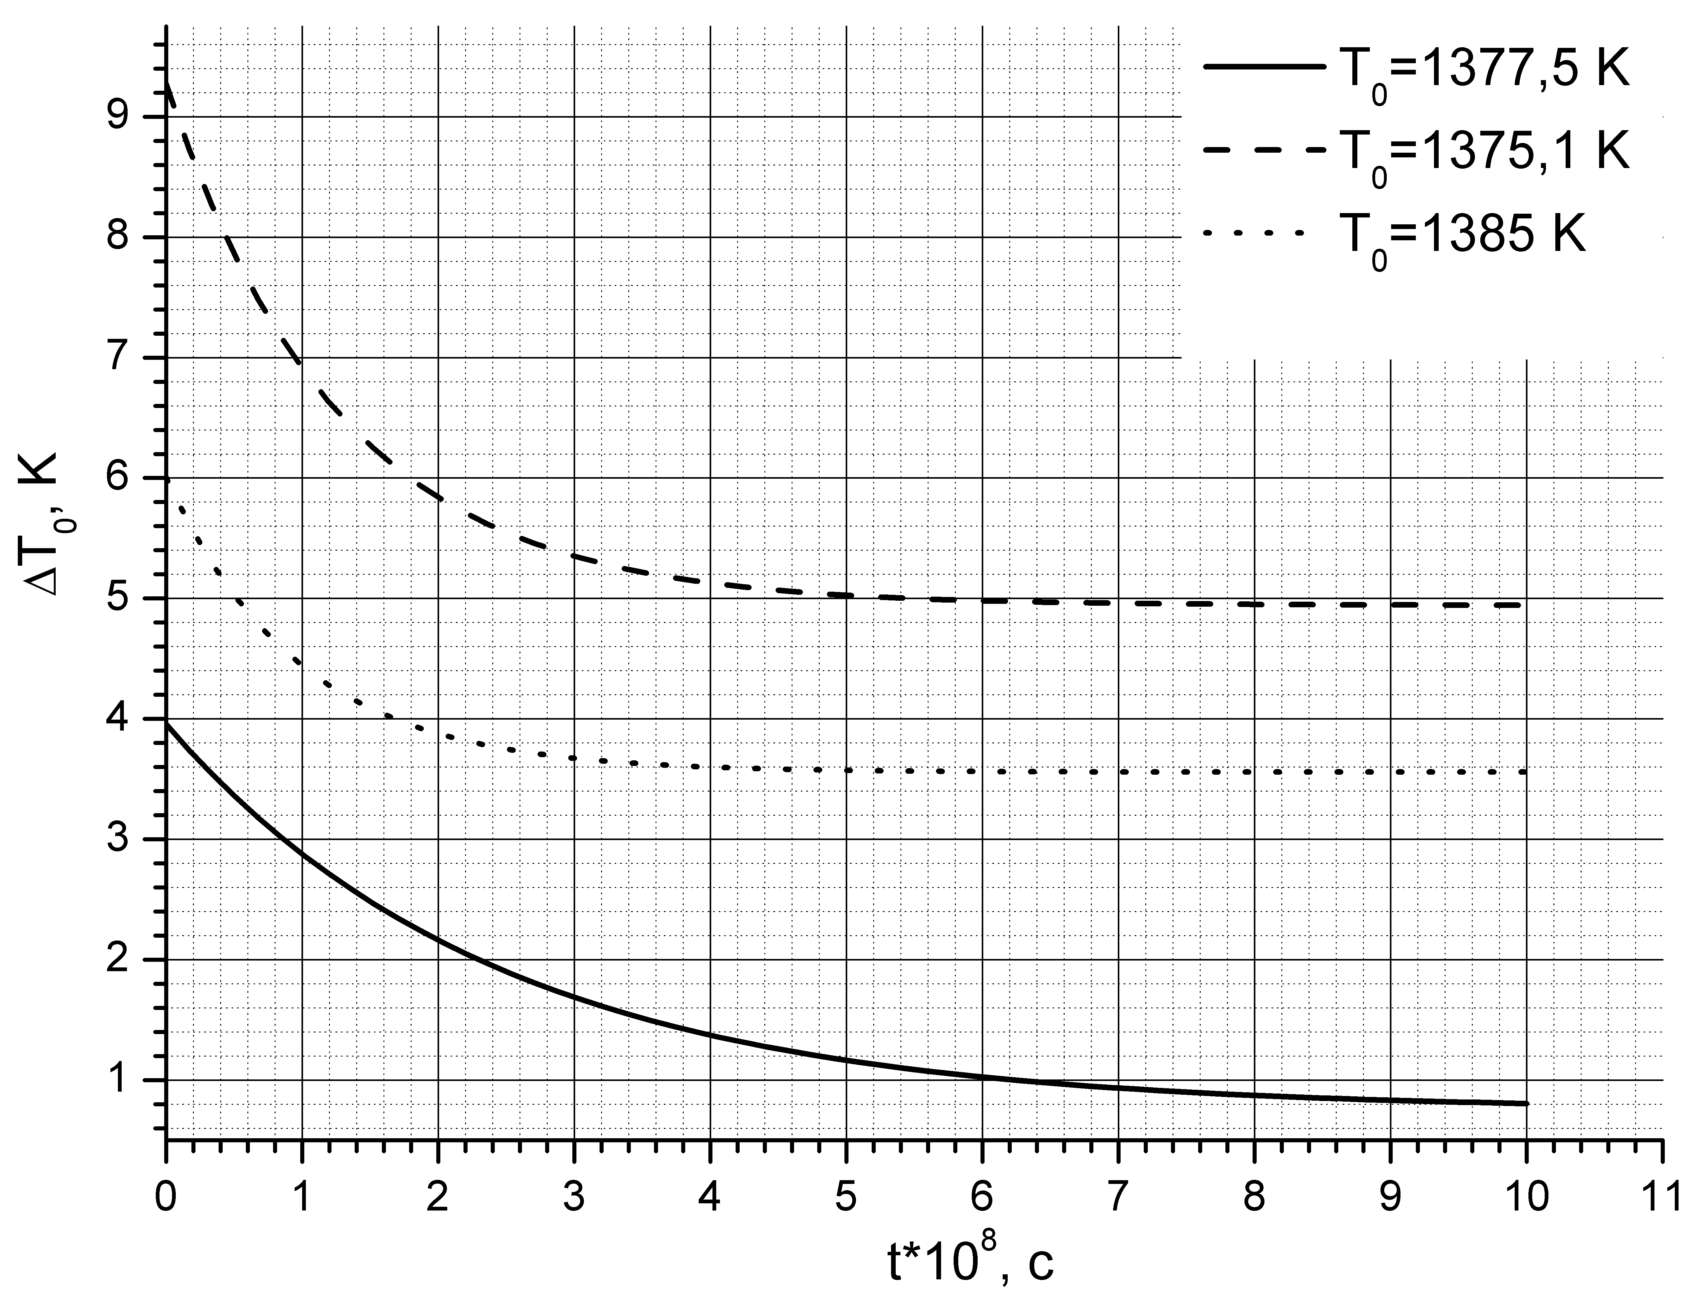

Fig. 1. Change of temperature of a solution in time

