DIFFUSION CONSTANT of PHOSPHORUS in GALLIUM at a PHASE
BOUNDARY at LIQUID-PHASE EPITAXY of GALLIUM PHOSPHIDE

Huhryanskiy J.P., Shunikov E.A.
Voronezh State Technical University (Voronezh, Russia)
eu_sh@mail.ru

The method of the molecular dynamics leads examinations of process of growth of a crystal of gallium phosphide from a liquid phase to the initial moment of time.

Interaction between atoms of a liquid phase was featured with the help of a combination of potentials of Born - Mayer and Lennard-Jones.
$V(r)=A\text{exp}\left(−ra\right)$, (1)
$V(r)=\frac{D}{n−m}\left[m{\left(\frac{r_{0}}{r}\right)}^{n}−n{\left(\frac{r_{0}}{r}\right)}^{m}\right]$. (2)
For the description of interaction between atoms of a crystal and atoms of a liquid phase the potential having axial symmetry of a view used
$V(r,z)=3,5\text{cos}\left(\frac{8r}{a}\right)\text{exp}\left(−\frac{\text{16}r^{2}}{a^{2}}\right)\text{exp}\left(−\frac{(z−a)^{2}}{a^{2}}\right)$, (3)
where $r=\sqrt{x^{2}+y^{2}}$.

As have shown experiments, forming near to a surface of a crystal of a transition layer slows down process of diffusion of atoms of a solution (fig. 1) in comparison with volume of a solution. To explain this phenomenon it is possible two reasons: change of the sizes of clusters and change of height of the transition δ-layer.
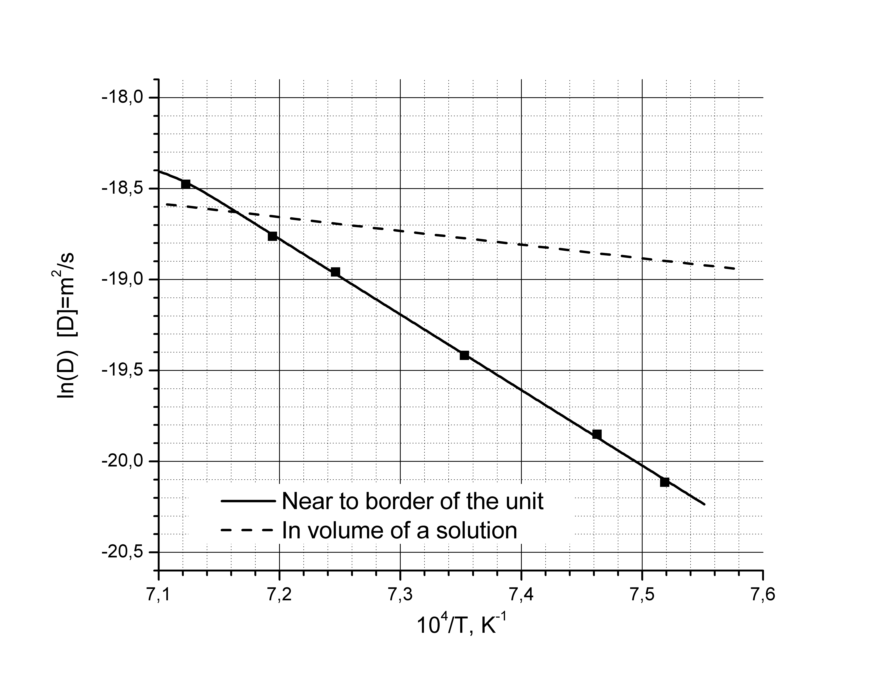
Fig. 1

